

Illinois E conomic Review

The Monthly Illinois Economic Review contains information on national, statewide, and local economic performance by measuring job growth, unemployment, and business activity. This information is compiled by IGPA Economist Geoffrey Hewings, Emeritus Director of the Regional Economics Applications Laboratory at the University of Illinois at Urbana-Champaign with assistance from Ivan Flores, and Youngwook Jung.

APRIL 2021

EMPLOYMENT

# employment data summary

* Illinois gained 32,200 jobs in March 2021, compared to a revised 37,300-job gain in February 2021. Compared to March 2020, Illinois has lost 360,700 jobs. The three-month moving average, a more stable measure of the labor market, showed an increase of 30,900 jobs per month.
* The Nation gained 916,000 jobs at a rate of 0.64% in March, compared with a revised 468,000-job gain in February 2021. The three-month moving average was up by 539,000 jobs per month.
* The RMW gained 73,400 jobs in March after a 40,500-job gain in February 2021. The three-month moving average was up by 64,300 jobs per month.
* The state of Illinois now has 251,900 fewer jobs than in December 2007 when the Great Recession started.
* Since January 2010, when Illinois employment growth resumed after the Great Recession, Illinois has gained 149,400 new jobs.
* The shadow unemployment rates for Illinois, RMW and the Nation were 15.7%, 12.6% and 13.2%, compared to official unemployment rates of 7.1%, 4.4% and 6.0%.
* Through March 2021, the cumulative job growth for Illinois, RMW and the Nation compared to January 1990 stood at 8.76%, 15.08%, and 31.98%, respectively.

# APRIL 2021 employment chart

|  |  |  |  |  |  |  |
| --- | --- | --- | --- | --- | --- | --- |
| **April**  **2021**  **Positive** | **Total Non-Farm Employment** | **Feb 2021 – Mar 2021** | | **Last 12 months** | | **Mar 2021** |
| **Growth Rate %** | **Number of Jobs** | **Growth Rate %** | **Number of Jobs** | **Shadow U.R. \*\*** |
| **Nation** | **0.64** | **916,000** | **-4.46** | **-6,720,000** | **13.25** |
| **RMW\*** | **0.37** | **73,400** | **-4.47** | **-919,500** | **12.57** |
| **Illinois** | **0.57** | **32,200** | **-5.92** | **-360,700** | **15.68** |

*RMW stands for Rest of the Midwest including six states, Indiana, Iowa, Michigan, Missouri, Ohio and Wisconsin.  
**REAL has estimated a *shadow unemployment rate*; this is calculated as the unemployment rate that would be observed if labor force participation rates matched the average for the 15-year period from 1990 to 2004.

|  |
| --- |
| Total non-farm Employment growth rate Jan 1990 – March 2021 |
|  |

|  |
| --- |
| Last 12 months Total Non-farm Employment Growth Rates apr 2020 – mar 2021 |
|  |

|  |
| --- |
| **Total Non-farm Employment growth rate by Sector feb 2021 – mar 2021** |
|  |

# Shadow unemployment

**Unemployment Rate: Official and Shadow**

The unemployment rate estimates the percentage of workers in the labor force who are currently unemployed but who are seeking work. The labor force participation rate is the percentage of the population 16 and older who are either working or actively seeking work. The participation rate has declined since the 1990s and thus a number of analysts feel that the official unemployment rate does not account for a larger number of people who have dropped out of the labor force. REAL has estimated a shadow unemployment rate; this is calculated as the unemployment rate that would be observed if labor force participation rates matched the average for the 15-year period from 1990 to 2004.

* In the 1990s, the average participation rate was 68.2% in Illinois whereas in 2010, it had declined to only 66.6%.
* For the 15 years from 1990 to 2004, the average participation rate was 68.1% in Illinois.
* In the 1990s in the US, the average participation rate was 65.5% whereas in 2010, it has been 66.0%; for the 15 years from 1990 to 2004, the average participation rate was 66.6%.
* The figures on the next page show the difference between the official and shadow unemployment rate for Illinois (top figure) and the US as a whole (bottom figure).
* After 2000, the gap between Illinois’s official and shadow unemployment rates increased until 2006 when it began to shrink. However, the gap started to increase again in 2010.
* To bring the two together in March 2021, a further 586,700 jobs would need to be created in Illinois.

* **Illinois**

* **US**

# Employment Forecast

|  |  |  |  |  |
| --- | --- | --- | --- | --- |
| **Illinois** | **March**  **2021** | **March 2022 (p)** | **Number of Jobs** | **Growth Rate %** |
| **Total non-farm** | 5,730,000 | 6,056,900 | 326,900 ~ 343,000 | 5.71% ~ 6.08% |
| Construction | 222,700 | 237,900 | 15,200 | 6.83% |
| Manufacturing | 547,400 | 562,800 | 15,400 | 2.81% |
| Trade, transportation & utilities | 1,181,400 | 1,291,900 | 110,500 | 9.35% |
| Information | 86,000 | 86,900 | 900 | 1.05% |
| Financial Activities | 401,500 | 418,900 | 17,400 | 4.33% |
| Professional & business services | 918,200 | 972,800 | 54,600 | 5.95% |
| Education & health | 891,500 | 943,700 | 52,200 | 5.86% |
| Leisure & hospitality | 457,400 | 467,500 | 10,100 | 2.21% |
| Other services | 236,000 | 259,700 | 23,700 | 10.04% |
| Government | 781,400 | 814,800 | 33,400 | 4.27% |

* The values by sector for the number of jobs added are the lower bound of the forecast.



Employment Forecast for MSAs

|  |  |  |  |  |  |  |  |
| --- | --- | --- | --- | --- | --- | --- | --- |
| **MSAs** | **February 2021\*** | **February 2022 (p)\*** | **Number of Jobs \*** | **Growth Rate %** | **Growth** | **Sector with**  **Highest**  **Growth Rate**  **(p)** | **Sector with Lowest Growth Rate (p)** |
| **Bloomington-Normal** | 86,200 | 87,400 | 1,200 ~ 1,300 | 1.35% ~ 1.56% | + | GOV (7.20%) | INF (-17.38%) |
| **Champaign-Urbana-Rantoul** | 111,900 | 111,400 | -100 ~ -500 | -0.03% ~ -0.42% | - | LEI (4.75%) | MAN (-3.97%) |
| **Chicago** | 3,861,100 | 4,099,800 | 228,900 ~ 238,700 | 5.93% ~ 6.18% | + | LEI (53.46%) | INF (-3.34%) |
| **Davenport-Rock Island-Moline** | 174,600 | 186,700 | 12,100 ~ 13,700 | 6.96% ~ 7.83% | + | PRO (13.69%) | INF (-1.81%) |
| **Decatur** | 46,400 | 47,400 | 1,000 ~ 1,300 | 2.15% ~ 2.86% | + | LEI (13.12%) | INF (-10.39%) |
| **Kankakee** | 42,300 | 43,300 | 1,000 ~ 1,600 | 2.36% ~ 3.81% | + | LEI (12.10%) | TTU (0.31%) |
| **Peoria** | 158,100 | 173,200 | 15,100 ~ 17,200 | 9.53% ~ 10.88% | + | LEI (42.23%) | FIN (2.95%) |
| **Rockford** | 137,500 | 139,700 | 2,200 ~ 2,600 | 1.59% ~ 1.89% | + | INF (22.21%) | CON (-4.96%) |
| **Springfield** | 101,300 | 103,100 | 1,800 ~ 2,600 | 1.77% ~ 2.52% | + | INF (16.28%) | CON (-3.95%) |

*Total Non-farm Jobs













Barometer of Job Recovery

|  |  |  |
| --- | --- | --- |
| **Illinois Recovery Scenarios** | | |
| **To Recover** | **Growth Rate** | |
| At the point of  2021 – March | At the point of 2010-June |
| In 5 years | 182,100 jobs/year | 206,200 jobs/year |
| In 8 years | 113,800 jobs/year | 128,900 jobs/year |
| In 10 years | 91,100 jobs/year | 103,100 jobs/year |
| In 15 years | 60,700 jobs/year | 68,700 jobs/year |

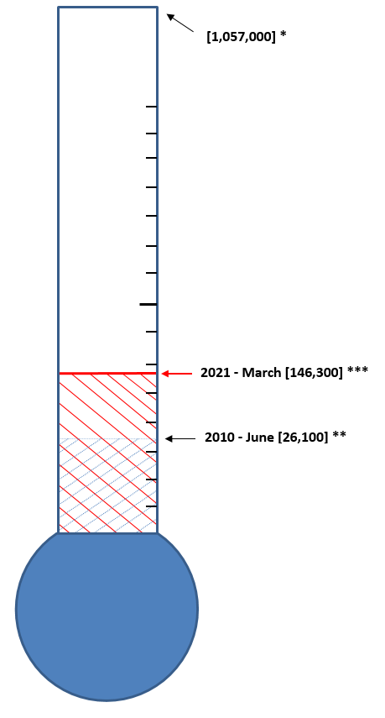

* The figure 1,057,000 is the number of jobs needed for the Illinois economy to recover to the previous employment peak, Nov-2000 adjusting for population growth and labor force participation rates. The gap between the previous peak, Nov-2000 and the previous lowest point, Dec-2009 is 470,300. The number of additional jobs that needed to be created after taking the shadow unemployment rate into account is 586,700to reach the adjusted target of 1,057,000.

** The figure 26,100 represents the jobs recovered from December 2009 (previous lowest level) through June 2010.

*** The figure 146,300 represents the jobs recovered from December 2009 through March 2021.

# Catch up Scenario

# & Recovery from Recession

Catch-up Scenario[1]* of Previous Peak Job Index in Illinois

|  |  |  |  |  |
| --- | --- | --- | --- | --- |
|  | **Previous Peak** | **Current** | **Catch-up** | **Recovery Rates** |
| **Nation** | 126.49  (Dec-2007) | 131.98  (March 2021) | Positive  growth | - |
| **RMW** | 119.39  (Jun-2000) | 115.08  (March 2021) | Positive  growth | 87.67% |
| **IL** | 115.00  (Nov-2000) | 108.78  (March 2021) | Negative  growth | -39.11% |
| Metro Areas[2]***: | | | | |
| **Bloomington Normal** | 142.06  (Feb 2002) | 121.02  (February 2021) | Negative  growth | NA |
| **Champaign- Urbana** | 116.26  (Jan 2009) | 113.93  (February 2021) | Positive  growth | - |
| **Chicago** | 114.82  (Nov 2000) | 108.50  (February 2021) | Positive  growth | 50.32% |
| **Davenport- Rock Island-Moline** | 115.06  (Mar 2008) | 105.85  (February 2021) | Negative  growth | NA |
| **Decatur** | 112.38  (Jan 2000) | 86.25  (February 2021) | Negative growth | NA |
| **Kankakee** | 125.66  (Nov 2011) | 117.86  (February 2021) | Positive  growth | 54.08% |
| **Peoria** | 122.09  (Aug 2008) | 102.55  (February 2021) | Negative  growth | NA |
| **Rockford** | 122.81  (Nov 2000) | 102.12  (February 2021) | Negative  growth | NA |
| **Springfield** | 110.94  (Aug 2000) | 96.01  (February 2021) | Negative  growth | NA |
| **Metro-East** | 114.97  (Jun 2001) | 105.26  (February 2021) | Negative  growth | NA |

cbai decreased in february

This index is based on national indices of leading indicators and is a barometer for the economy, tracing the path of growth or contraction through to the current period and then forecasts up to 24 months into the future.

* The Chicago Business Activity Index (CBAI) decreased to 139.0 in February from 248.2 in January. The decrease is mainly attributed to negative construction job growth and a sharp decline in expected retail sales. However, these figures are very different compared to the previous CBAI, moving between 90 and 110. The unprecedented COVID-19 shock caused the CBAI to plummet and the index to deviate dramatically from trend. After the index recorded the lowest value in July, 2020, the CBAI predicted a rapid economic recovery, leading the index to return into the trend. However, a longer-than-expected COVID-19 shock and the occurrence of several new waves of infections has delayed economic recovery and caused unstable monthly changes in the CBAI. Therefore, it is important to monitor employment and production in detail, as well as changes in the CBAI.
* In February, total industrial production fell 2.2 percent. Manufacturing output decreased 3.1 percent, and at 104.7 percent of its 2012 average, total industrial production was 4.2 percent lower than it was a year earlier.
* Capacity utilization for the industrial sector decreased 1.7 percentage point to 73.8 percent, a rate that is 5.8 percentage points below its long-run (1972–2020) average. The Chicago Fed reported that the Chicago Fed National Activity Index (CFNAI) moved down to -1.09 in February from 0.75 in January. In the Chicago region, employment in the manufacturing sector increased 0.49 percent and employment in the nonmanufacturing sector increased 0.47 percent in February. Employment in the construction sector decreased 1.90 percent and retail sales are estimated to have decreased 2.29 percent during the same period.
* Total US nonfarm payroll employment increased by 916,000 in March, and the unemployment rate decreased to 6.0 percent. Employment indicators are gradually improving nationwide, but a limited resumption of economic activity is expected in the coming months at the Chicago area.

|  |  |  |  |
| --- | --- | --- | --- |
| **CBAI** (Current: 139.0) | | | |
|  | | | |
|  | 1 month | 3 month | 1 year |
| Historical (ago) | 248.2 | 82.5 | 96.6 |
| Forecast (ahead) | 76.6 | 105.6 | - |

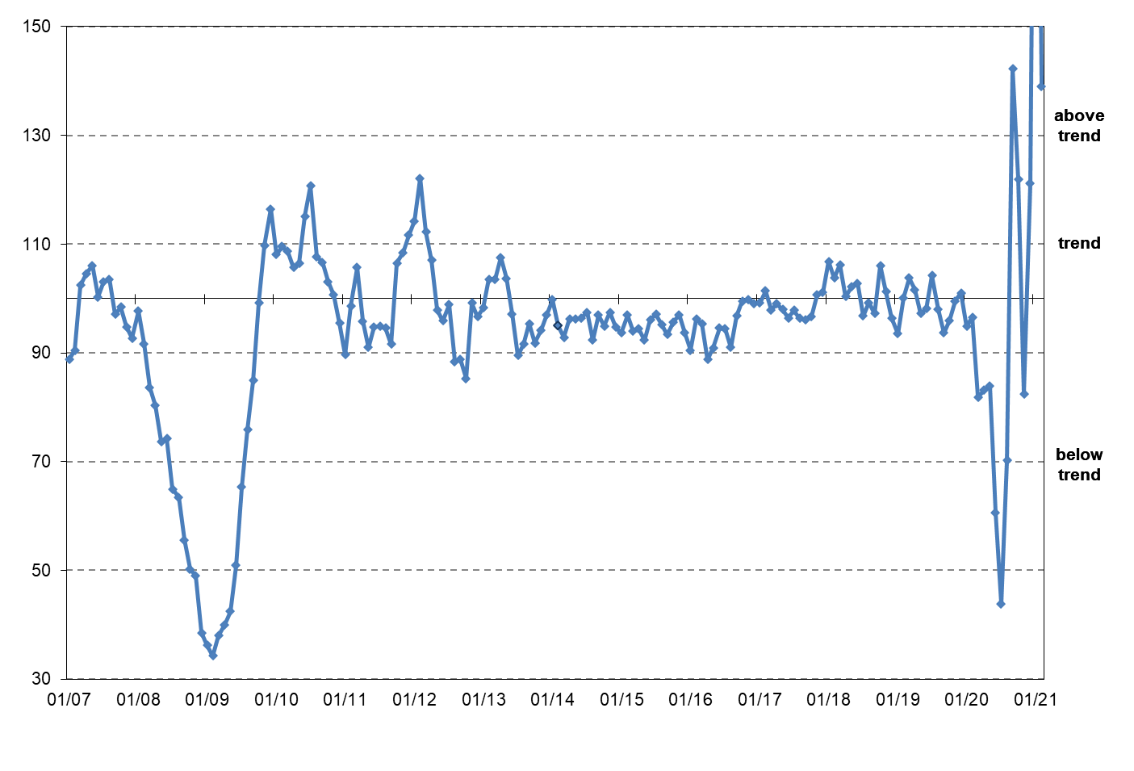**Chicago Business Activity Index**

METROPOLITAN STATISTICAL AREA LEAGUE TABLES

# MSA LEAGUE TABLES SUMMARY*

* Decatur (1st to 6th) experienced the deepest fall in February 2021.
* The most remarkable upward move in February was record for Springfield (9th to 2nd), Rockford (6th to 3rd), and Davenport-Rock Island-Moline (8th to 5th).
* In the 12-month growth league table, upward move was recorded for Champaign-Urbana-Rantoul (6th to 1st), Springfield (8th to 4th), Rockford (7th to 6th), and Kankakee (10th to 9th).
* Downward moves were recorded for Chicago (2nd to 4th), Decatur (1st to 6th), Peoria (4th to 8th), and Bloomington-Normal (9th to 10th).
* In the 12-month growth league table, Champaign-Urbana-Rantoul moved up to the first place and Chicago moved down to the last place of the rank.

*NOTE: The US Bureau of Labor Statistics and the Illinois Department of Employment Security changed the way national and state employment data are coordinated to be more consistent. As a result, there have been some significant changes in estimates for Illinois over the past year.

**MSA League Tables[3]*: Non-farm Employment Growth Rate**

**Monthly growth:**

|  |  |  |  |  |
| --- | --- | --- | --- | --- |
| **Rank** | **January 2021** | **February 2021** | **Rank** | **Change\*\*** |
| 1 | Decatur (0.3%) | Kankakee (1.58%) | 1 | **🡅 (+2)** |
| 2 | Chicago (0.2%) | Springfield (0.86%) | 2 | **🡅 (+3)** |
| 3 | Kankakee (0.14%) | Rockford (0.63%) | 3 | **🡅 (+3)** |
| 4 | Peoria (0.13%) | Chicago (0.49%) | 4 | **🡇 (-2)** |
| 5 | Springfield (0.09%) | Davenport-Rock Island-Moline (0.48%) | 5 | **🡅 (+3)** |
| 6 | Rockford (0.05%) | Decatur (0.41%) | 6 | **🡇 (-5)** |
| 7 | Champaign-Urbana-Rantoul (-0.19%) | Champaign-Urbana-Rantoul (0.24%) | 7 | **🡄 (+0)** |
| 8 | Davenport-Rock Island-Moline (-0.32%) | Peoria (0.05%) | 8 | **🡇 (-4)** |
| 9 | Bloomington-Normal (-0.35%) | Metro-East (-0.28%) | 9 | **🡅 (+1)** |
| 10 | Metro-East (-1.07%) | Bloomington-Normal (-0.34%) | 10 | **🡇 (-1)** |

**Growth over last 12-months:**

|  |  |  |  |  |
| --- | --- | --- | --- | --- |
| **Rank** | **January 2021** | **February 2021** | **Rank** | **Change\*\*** |
| 1 | Metro-East (-4.88%) | Champaign-Urbana-Rantoul (-2.8%) | 1 | **🡅 (+5)** |
| 2 | Davenport-Rock Island-Moline (-6.36%) | Metro-East (-5.33%) | 2 | **🡇 (-1)** |
| 3 | Bloomington-Normal (-6.96%) | Davenport-Rock Island-Moline (-6.15%) | 3 | **🡇 (-1)** |
| 4 | Peoria (-7.18%) | Springfield (-6.43%) | 4 | **🡅 (+4)** |
| 5 | Decatur (-7.48%) | Bloomington-Normal (-6.83%) | 5 | **🡇 (-2)** |
| 6 | Champaign-Urbana-Rantoul (-7.55%) | Rockford (-7.3%) | 6 | **🡅 (+1)** |
| 7 | Rockford (-7.87%) | Decatur (-7.44%) | 7 | **🡇 (-2)** |
| 8 | Springfield (-7.94%) | Peoria (-7.65%) | 8 | **🡇 (-4)** |
| 9 | Chicago (-8.91%) | Kankakee (-8.22%) | 9 | **🡅 (+1)** |
| 10 | Kankakee (-9.92%) | Chicago (-8.58%) | 10 | **🡇 (-1)** |

Unemployment: Initial Claims (US and Illinois)



1. * Catch-up scenarios compares a region’s current employment with its historical peak. The US has surpassed its historical peak level but RMW and Illinois have not. In the “Recovery Rates” column, “ - ” means the region has fully recovered from the recession, “ NA” means the region did not lose jobs during that period or perceives a negative recovery rate, and a percentage indicates the ratio of recovered jobs to all jobs lost during the recession.
2. *** Due to lag of data release schedule there is one month of time lag in the catch-up scenario for metro areas.

   NOTE: The US Bureau of Labor Statistics and the Illinois Department of Employment Security changed the way national and state employment data are coordinated to be more consistent. As a result, there have been some significant changes in estimates for Illinois over the past year.
3. * MSA League Tables are based on revised employment data. For instances of equal growth rate for multiple MSAs ranks are decided based on change of growth rate from previous month.