|  |  |  |  |
| --- | --- | --- | --- |
| Illinois Job Index | | | |
| Release  04/29/2021 | Data  Jan 1990 /Mar 2021 | Issue  2021.04 | www.real.illinois.edu |

**For March 2021 Illinois, RMW and the nation Job Index showed employment increase.**

The Illinois Job Index and MSA Report are issued monthly as tools for elected officials, policy leaders and the public. The objective is to enhance the understanding of the Illinois economy and business climate by comparing and measuring Illinois employment growth rates against those of the Rest of the Midwest (RMW: Indiana, Iowa, Michigan, Missouri, Ohio and Wisconsin) and the Nation. Data and analysis are provided by the Illinois Economic Observatory / Regional Economics Applications Laboratory, University of Illinois.

|  |  |  |  |  |  |  |  |
| --- | --- | --- | --- | --- | --- | --- | --- |
| **↑** | April  2021  Positive |  | Feb 2021 – Mar 2021 | | Last 12 months | | Mar 2021 |
| Total non-farm employment | **Growth Rate %** | **Number of Jobs** | **Growth Rate%** | **Number of Jobs** | **Shadow U.R.\*** |
| **Nation** | **0.64** | **916,000** | **-4.46** | **-6,720,000** | **13.25** |
| **RMW** | **0.37** | **73,400** | **-4.47** | **-919,500** | **12.57** |
| **Illinois** | **0.57** | **32,200** | **-5.92** | **-360,700** | **15.68** |

*REAL has estimated a *shadow unemployment rate*; this is calculated as the unemployment rate that would be observed if labor force participation rates matched the average for the 15-year period from 1990 to 2004.

|  |  |
| --- | --- |
| Talking Points | |
| Illinois  Notes | * Illinois gained 32,200 jobs in March 2021, compared to a revised 37,300-job gain in February 2021. Compared to March 2020, Illinois has lost 360,700 jobs. The three-month moving average, a more stable measure of the labor market, showed an increase of 30,900 jobs per month. * The Nation gained 916,000 jobs at a rate of 0.64% in March, compared with a revised 468,000-job gain in February 2021. The three-month moving average was up by 539,000 jobs per month. * The RMW gained 73,400 jobs in March after a 40,500-job gain in February 2021. The three-month moving average was up by 64,300 jobs per month. * The state of Illinois now has 251,900 fewer jobs than in December 2007 when the Great Recession started. * In 2021, Illinois had employment growth for three months. * Three sectors in Illinois have employment levels this month that are lower than January 1990 – Construction, Manufacturing, and Information. * Since January 2010, when Illinois employment growth resumed after the Great Recession, Illinois has gained 149,400 new jobs. * By March 2022, Trade, transportation & utilities, Financial activities, and Professional & business will be fully recovered to their employment levels before the recession. The 12-month-ahead job recovery forecasts show that the future recovery rates in Illinois will increase for every sector. * The shadow unemployment rates for Illinois, RMW and the Nation were 15.7%, 12.6% and 13.2%, compared to official unemployment rates of 7.1%, 4.4% and 6.0%. * Through March 2021, the cumulative job growth for Illinois, RMW and the Nation compared to January 1990 stood at 8.76%, 15.08%, and 31.98%, respectively. |
| Nation  Notes | * Total nonfarm payroll employment was up by 916,000 jobs. Sectors such as Leisure & hospitality, Construction, and Other Services had major job growth. * The nation has recovered from the Great Recession and gained 5,711,000 additional jobs since the last employment peak in December 2007. RMW and Illinois have respectively lost 746,700 and 323,600 jobs from their peaks in 2000. * The nation’s annual average growth rates from 2007 to 2021 were -0.01%, -0.24%, -0.38%, 0.09%, 0.13%, 0.11%, 0.12%, 0.14%, 0.12%, 0.03%, 0.12%, 0.15%, 0.12%, -0.44%, 0.38% respectively. |

|  |  |  |  |  |  |
| --- | --- | --- | --- | --- | --- |
| Total Non-farm Employment and Employment Index | | | | | |
|  | **March 2021**  **Number of Jobs** | **Current**  **Index to Jan 1990** | **Previous Peak**  **Index to Jan 1990** | **Changes in Jobs since Jan 1990** | **Changes in Jobs since Pervious Peak** |
| **Nation** | 144,120,000 | 131.98 | 126.57 (Dec-2007) | 34,923,000 | 5,711,000 |
| **RMW** | 19,667,200 | 115.08 | 119.44 (Jun-2000) | 2,576,600 | -746,700 |
| **Illinois** | 5,730,000 | 108.76 | 115.08 (Nov-2000) | 461,700 | -323,600 |

|  |
| --- |
| Total Non-farm Employment growth rate Jan 1990 – Mar 2021 |
|  |

|  |
| --- |
| Last 12 months Total Non-farm Employment Growth Rates Apr 2020 – Mar 2021 |
|  |

Barometer of Job Recovery

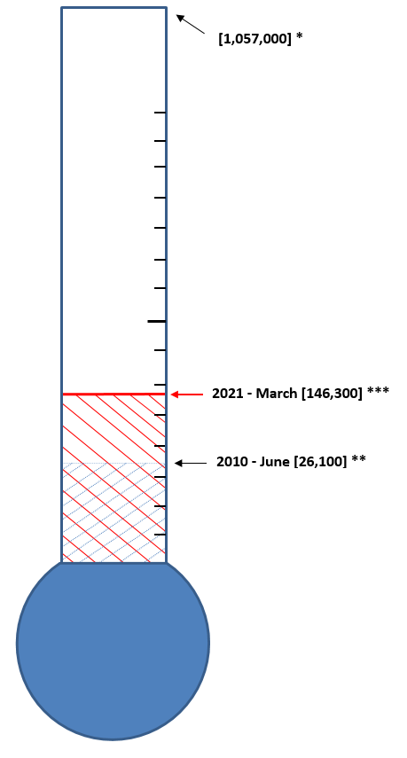

|  |  |  |
| --- | --- | --- |
| **Illinois Recovery Scenarios** | | |
| **To Recover** | **Growth Rate** | |
|  | At the point of 2021 – March | At the point of 2010-June |
| In 5 years | 182,100 jobs/year | 206,200 jobs/year |
| In 8 years | 113,800 jobs/year | 128,900 jobs/year |
| In 10 years | 91,100 jobs/year | 103,100 jobs/year |
| In 15 years | 60,700 jobs/year | 68,700 jobs/year |

* The figure 1,057,000 is the number of jobs needed for the Illinois economy to recover to the previous employment peak, Nov-2000 adjusting for population growth and labor force participation rates. The gap between the previous peak, Nov-2000 and the previous lowest point, Dec-2009 is 470,300. The number of additional jobs that needed to be created after taking the shadow unemployment rate into account is 586,700 to reach the adjusted target of 1,057,000.

**The figure 26,100 represents the jobs recovered from December 2009 (previous lowest level) through June 2010.

*** The figure 146,300 represents the jobs recovered from December 2009 through March 2021.

Barometer of Job Recovery (COVID-19 Recession)

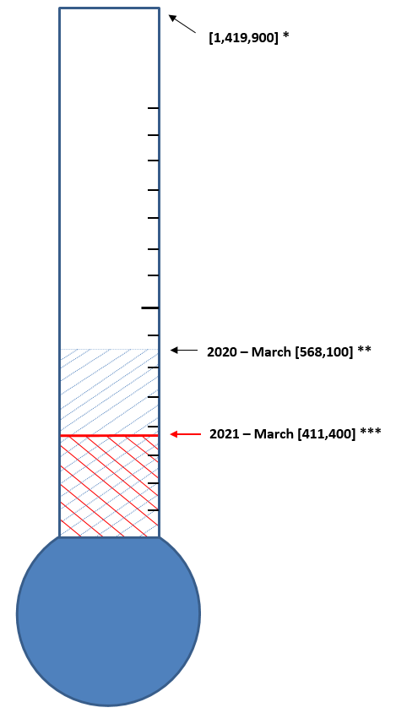

|  |  |  |
| --- | --- | --- |
| **Illinois Recovery Scenarios** | | |
| **To Recover** | **Growth Rate** | |
| At the point of 2021 – March | At the point of 2020-January |
| In 5 months | 201,700 jobs/month | 170,400 jobs/month |
| In 8 months | 126,100 jobs/month | 106,500 jobs/month |
| In 10 months | 100,900 jobs/month | 85,200 jobs/month |
| In 15 months | 67,200 jobs/month | 56,800 jobs/month |

* The figure 1,419,900 is the number of jobs needed for the Illinois economy to recover to the previous employment peak, Jan-2020 adjusting for population growth and labor force participation rates. The gap between the previous peak, Jan-2020 and the lowest point, Apr-2020 is 833,200. The number of additional jobs that needed to be created after taking the shadow unemployment rate into account is 586,700 to reach the adjusted target of 1,419,900.

**The figure 568,100 represents the jobs recovered from December 2009 (previous lowest level) through January 2020.

*** The figure 411,400 represents the jobs recovered from April 2020 through March 2021.

Employment Growth Rate by Sector:

|  |
| --- |
| Total Non-Farm Employment growth rate by Sector, Feb 2021 – Mar 2021 |
|  |

|  |  |
| --- | --- |
| Sector notes | * Illinois posted positive employment change in March 2021 by adding 32,200 jobs. Six out of ten sectors recorded net gains. Compared to February 2021, Construction (-1.10% to 2.91%) had the greatest performance gain, while Leisure & hospitality (7.72% to 3.09%) experienced the greatest performance loss. Other Services (-0.04% to 0.85%), Professional & business services (-0.13% to 0.69%), Education & health (0.00% to 0.58%), Trade, transportation & utilities (0.03% to 0.17%), and Financial activities (-0.20% to -0.17%) also experienced performance gain. * In March at the national level, the top three job-gain sectors were:   + Leisure & hospitality: 280,000 (2.07%)   + Construction: 110,000 (1.50%)   + Other Services: 42,000 (0.76%) * For Illinois, the top three job-gain sectors in March were:   + Leisure & hospitality: 13,700 (3.09%)   + Construction: 6,300 (2.91%)   + Other Services: 2,000 (0.85%) * The three sectors that lost jobs in March in Illinois were:   + Government: -2,600 (-0.33%)   + Information: -200 (-0.23%)   + Financial activities: -700 (-0.17%) * For Illinois, three sectors have employment below 1990 levels. Compared to 1990 employment levels, Construction has shed 7,700 jobs, while Manufacturing has shed 374,900 jobs, and Information has shed 45,200 jobs. |

|  |  |  |  |  |  |  |
| --- | --- | --- | --- | --- | --- | --- |
| **Total Non-farm Employment growth rate by sector July 1990 – March 2021** | | | | | | |
|  | **Illinois** | | | | **RMW** | **Nation** |
| **vs. RMW** | **vs.** | **Number of Jobs** | **Rate %** | **Rate** | **Rate** |
| **Nation** | **%** | **%** |
| **Construction** | **-** | **-** | **-7,700** | **-3.34** | **27.45** | **37.70** |
| **Manufacturing** | **-** | **-** | **-374,900** | **-40.65** | **-24.69** | **-30.98** |
| **Trade, transportation & utilities (TTU)** | **-** | **-** | **33,400** | **2.91** | **8.34** | **19.78** |
| **Information** | **-** | **-** | **-45,200** | **-34.45** | **-31.48** | **0.11** |
| **Financial activities** | **-** | **-** | **28,900** | **7.76** | **22.03** | **33.43** |
| **Professional & business services** | **-** | **-** | **344,800** | **60.13** | **71.99** | **92.07** |
| **Education & health** | **-** | **-** | **362,500** | **68.53** | **74.67** | **117.04** |
| **Leisure & hospitality** | **-** | **-** | **73,500** | **19.15** | **19.78** | **48.34** |
| **Other Services** | **+** | **-** | **30,400** | **14.79** | **12.43** | **31.27** |
| **Government** | **-** | **-** | **26,100** | **3.46** | **5.69** | **19.07** |

|  |  |  |  |  |  |
| --- | --- | --- | --- | --- | --- |
| Illinois job recovery by sector from Dec 2007 – Mar 2021 | | | | | |
|  | | | | | |
|  | **Job Changes in Recession Period\*** | **Job Changes in Jan 2010 - Mar 2021** | **Recovery Rate** | **Forecasted Job Changes Jan 2010 -Mar 2022** | **Forecasted Recovery Rate** |
| **Construction** | **-64,000** | **18,700** | **29.22%** | **34,000** | **53.13%** |
| **Manufacturing** | **-114,700** | **-8,000** | **-6.97%** | **7,900** | **6.89%** |
| **Trade, transportation & utilities (TTU)** | **-97,600** | **63,900** | **65.47%** | **171,000** | **175.20%** |
| **Information** | **-11,600** | **-18,000** | **-155.17%** | **-17,100** | **-147.41%** |
| **Financial activities** | **-32,600** | **27,600** | **84.66%** | **53,900** | **165.34%** |
| **Professional & business services** | **-93,100** | **145,200** | **155.96%** | **199,800** | **214.61%** |
| **Education & health** | **34,000** | **70,200** | **-** | **122,400** | **-** |
| **Leisure & hospitality** | **-22,200** | **-54,600** | **-245.95%** | **-44,500** | **-200.45%** |
| **Other services** | **-5,700** | **-20,100** | **-352.63%** | **3,600** | **63.16%** |
| **Government** | **7,000** | **-73,100** | **-** | **-41,500** | **-** |

*Recession period: Dec 2007- Dec 2009

|  |  |
| --- | --- |
| Recovery by Sector | * During the recession period of December 2007-December 2009, 8 out of 10 Illinois sectors experienced employment declines. Education & health and Government were the only 2 sectors that had positive job growth during the recession. * Since January 2010, Illinois employment growth resumed. Construction, Trade, transportation & utilities, Financial activities, and Professional & business services, have recovered 29.22%, 65.47%, 84.66%, and 155.96% respectively from the jobs lost during the recession. * By March 2022, Trade, transportation & utilities, Financial activities, and Professional & business services will be fully recovered to their employment levels before the recession. * However, the recovery rate for Information and Leisure & hospitality is still negative, namely -147.41%, and -200.45% respectively. * The 12-month-ahead job recovery forecasts show that the future recovery rates in Illinois will increase for every sector. |

|  |  |  |  |  |
| --- | --- | --- | --- | --- |
| Construction | Feb 2021 - Mar 2021 |  | Feb 2021 - Mar 2021 | |
|  | |  | **%**  **Change** | **Number of Jobs** |
| Illinois | **2.91** | **6,300** |
| RMW | **2.70** | **23,100** |
| Nation | **1.50** | **110,000** |

|  |  |  |  |  |
| --- | --- | --- | --- | --- |
| Manufacturing | Feb 2021 - Mar 2021 |  | Feb 2021 - Mar 2021 | |
|  | |  | **%**  **Change** | **Number of Jobs** |
| Illinois | **0.02** | **100** |
| RMW | **0.30** | **8,000** |
| Nation | **0.43** | **53,000** |

|  |  |  |  |  |
| --- | --- | --- | --- | --- |
| Trade, transportation & utilities (TTU) | Feb 2021 - Mar 2021 |  | Feb 2021 - Mar 2021 | |
|  | |  | **%**  **Change** | **Number of Jobs** |
| Illinois | **0.17** | **2,000** |
| RMW | **0.06** | **2,300** |
| Nation | **0.35** | **94,000** |

|  |  |  |  |  |
| --- | --- | --- | --- | --- |
| Information | Feb 2021 - Mar 2021 |  | Feb 2021 - Mar 2021 | |
|  | |  | **%**  **Change** | **Number of Jobs** |
| Illinois | **-0.23** | **-200** |
| RMW | **-0.45** | **-1,100** |
| Nation | **-0.07** | **-2,000** |

|  |  |  |  |  |
| --- | --- | --- | --- | --- |
| Financial activities | Feb 2021 - Mar 2021 |  | Feb 2021 - Mar 2021 | |
|  | |  | **%**  **Change** | **Number of Jobs** |
| Illinois | **-0.17** | **-700** |
| RMW | **0.17** | **1,900** |
| Nation | **0.18** | **16,000** |

|  |  |  |  |  |
| --- | --- | --- | --- | --- |
| Professional & business services | Feb 2021 - Mar 2021 |  | Feb 2021 - Mar 2021 | |
|  | |  | **%**  **Change** | **Number of Jobs** |
| Illinois | **0.69** | **6,300** |
| RMW | **0.10** | **2,500** |
| Nation | **0.32** | **66,000** |

|  |  |  |  |  |
| --- | --- | --- | --- | --- |
| Education & health | Feb 2021 - Mar 2021 |  | Feb 2021 - Mar 2021 | |
|  | |  | **%**  **Change** | **Number of Jobs** |
| Illinois | **0.58** | **5,100** |
| RMW | **0.53** | **16,800** |
| Nation | **0.43** | **101,000** |

|  |  |  |  |  |
| --- | --- | --- | --- | --- |
| Leisure & hospitality | Feb 2021 - Mar 2021 |  | Feb 2021 - Mar 2021 | |
|  | |  | **%**  **Change** | **Number of Jobs** |
| Illinois | **3.09** | **13,700** |
| RMW | **0.82** | **14,100** |
| Nation | **2.07** | **280,000** |

|  |  |  |  |  |
| --- | --- | --- | --- | --- |
| Other Services | Feb 2021 - Mar 2021 |  | Feb 2021 - Mar 2021 | |
|  | |  | **%**  **Change** | **Number of Jobs** |
| Illinois | **0.85** | **2,000** |
| RMW | **-0.05** | **-400** |
| Nation | **0.76** | **42,000** |

|  |  |  |  |  |
| --- | --- | --- | --- | --- |
| Government | Feb 2021 - Mar 2021 |  | Feb 2021 - Mar 2021 | |
|  | |  | **%**  **Change** | **Number of Jobs** |
| Illinois | **-0.33** | **-2,600** |
| RMW | **0.22** | **6,000** |
| Nation | **0.63** | **136,000** |

**ABOUT:** The Regional Economics Applications Laboratory (REAL) is a unit of the Institute of Government and Public Affairs of the University of Illinois. REAL undertakes impact and forecasting analyses of the Illinois and several Midwestern economies and is also engaged in similar analysis in several other countries including Brazil, Chile, Colombia, and Japan. More information can be found at [www.real.illinois.edu](http://www.real.uiuc.edu).